***LiveFly* - a toolbox for the analysis of transcription dynamics in live *Drosophila* embryos**

**MANUAL**

The *LiveFly* toolbox is designed to help users with quantitative analysis of transcription dynamics in live *Drosophila* embryos. The toolbox allows users to process two-color 3D confocal movies acquired using nuclei-labeling and the fluorescent RNA-tagging system described in the previous chapter and export the nuclei’s position as a function of time, their lineages and the intensity traces of the active loci. The toolbox, which is tailored for the context of *Drosophila* early development, is semi-automatic, and requires minimal user intervention. It also includes a tool to combine data from multiple movies and visualize several features of the intensity traces and the expression pattern.

# I. Overview:

## 1. System requirements

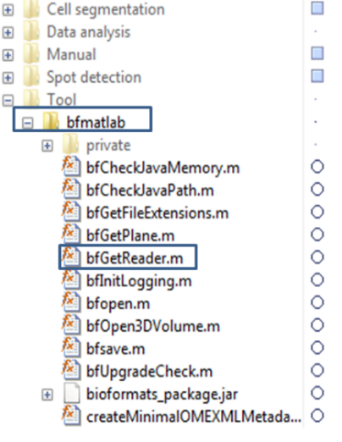1. MATLAB 2013 or above, with the Image Processing Toolbox

2. The *LiveFly* toolbox: available for download from: <https://github.com/huytran216/LiveFly_toolbox>

3. Bioformat’s MATLAB toolbox: version 5.2.1 or higher

-Download the toolbox from <https://www.openmicroscopy.org/bio-formats/downloads/>

-Extract the zipped file to ImgProc\_pipeline\Tool\bfmatlab

-bfGetReader.m should be found as in the following figures:

Additionally, you can install ImageJ or any tiff/lsm/czi manipulation software to visualize, extract or manipulate the images. In case of ImageJ, you need the Bioformat package for ImageJ, also downloaded from the link above.

## 2. Inputs

1. A time-lapse 3D movie captured with a confocal microscope. The compatible file formats are \*.tif, \*.czi or \*.lsm commonly used in time-lapse microscopy.

-Channel 1: (RED) Nuclear envelop for cell segmentation

-Channel 2: (GREEN) MCP-GFP/PP7 channel for monitoring of transcription activity

2. Experiment’s configuration, which includes:

-Number of image frame

-shift\_leftX, shift\_right (position of embryo poles relative to the captured frame)

-Time resolution: dt

-XY and Z resolution (µm/pixel)

-Anterior direction (left or right side of the image)

3. After the spot detection process, users need to create a “**correction.mat**” file:

- The file stores the experiment configuration, specifying bad cells, frames of interest…

-To be created manually

-This file is only useful when users want to use the included Visualizer. Otherwise, they can already access the movies’ information from the generated output files.

## 3. Output:

The program generates a number of output files after each steps. All output files are placed in the same folder as the input 3D movie.

1. Nuclei segmentation and lineage information:

-Typically “**\_Track.mat**” file

2. Spot intensity in each nuclei (the program is currently designed to detect one spot per nucleus) over time

-Example file: “**summary\_table/th57\_29.txt**”

-See Header.txt for output file format

3. Other miscellaneous files that are generated to save the progress of the nuclei segmentation and spot detection process.

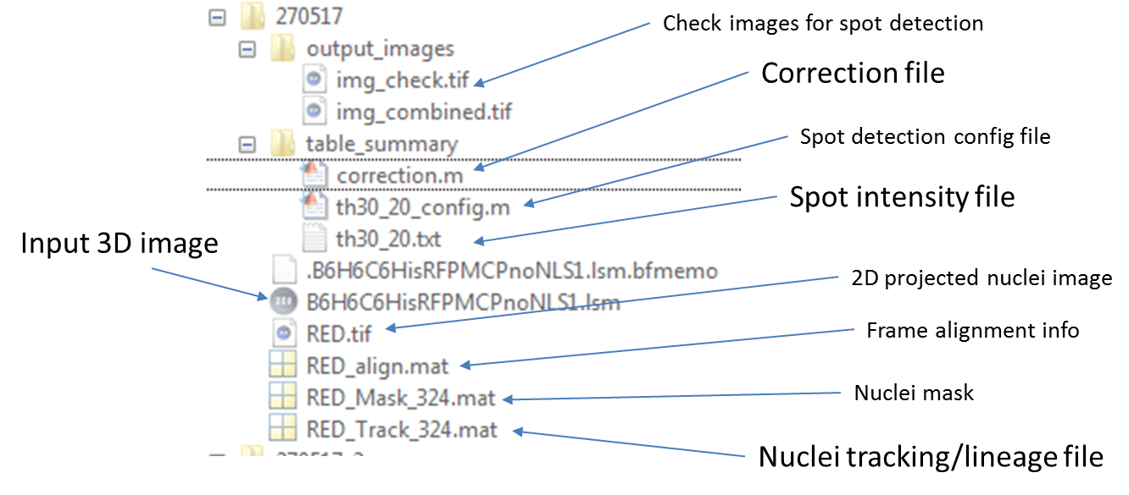

## 4. Work flow:

C:\Users\Anakine\Dropbox\REFLEX\METHOD_PAPER\Movie_analysis_tool\Fig1.tif

Modules of the *LiveFly* toolbox. (1) The Nuclei segmentation module extracts from the 3D movie’s nuclei channel (marked by either fluorescent histones or NUP) the temporal position and lineage of each nucleus. (2) The Spot detection module extracts the intensity trace of active transcription loci in each nucleus. (3) The Visualizer module allows users to manage the data from multiple movies and to visualize the pattern of several features of the transcription dynamics.

Yes, the modules look very daunting, and it seems there are bazillions of things to learn to master this tool! But don’t panic. After some trial/errors, you will find yourself processing a movie in less than half a day.

Let’s think of this manual as a lookup tool for what to do next.

# II. Nuclei segmentation

## 1. Create 2D movie for nuclei segmentation

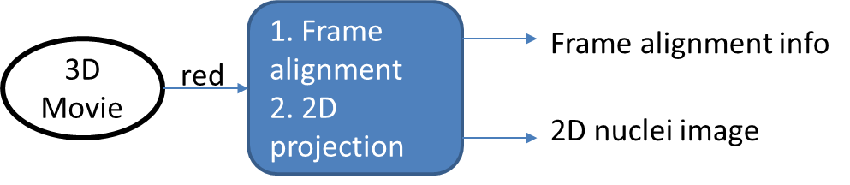

1. Open Cell segmentation/LiveFly\_CREATE\_PROJECTION.m

2. Specify the following parameters:

folder: movie file location (e.g. ..\Test\)

mov\_in: 3D movie input file name (e.g. “**RawMovie.tif**”)

mov\_out: 2D movie output file name (e.g. “**RED**”), without file extension

n\_frame: Range of frame to be analyzed (e.g. [1:220])

3. Additional parameters: see comments in .m file

4. Run the script (Press F5). A maximum projection movie from the raw input movie titled as mov\_out is created. The nuclei segmentation will be done based on this file (referred as “**RED.tif**”).

Also created is the file “**RED\_align.mat**” containing the frame-by-frame alignment information. This alignment information is used to predict a nuclei position in the next frame given the drift between the frames and crucial in tracking cell lineages.

## 2. The nuclei segmentation interface

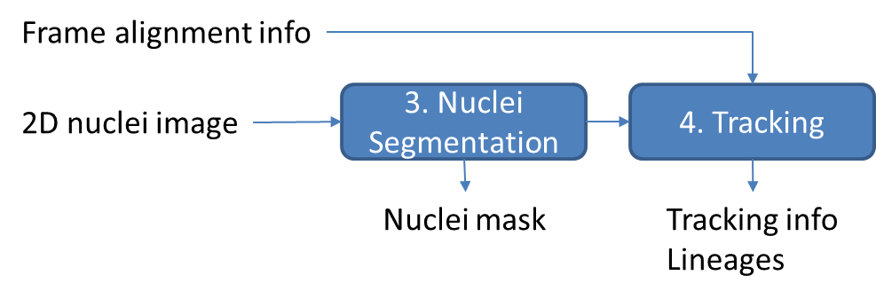

1. Run the script Cell segmentation/LiveFly\_SEGMENTATION.m

You expect to see an interface layout like the picture bellow:

C:\Users\Anakine\Dropbox\REFLEX\METHOD_PAPER\Movie_analysis_tool\Fig2.tif

2. Load the 2D movie “**RED.tif**”

-Click **Menu>File>Load image**, navigate to file “**RED.tif**” generated previously.

-Choose the number of time frame you wish to analyze. Set this value to either 0 will load all frames.

-Choose the nuclear cycle at frame 1.

3. Navigate through frames:

-Scroll mouse or controlling the slider at the GUI’s bottom to navigate through the frames.

-The frame index, and the number of nuclei detected is shown in the top left corner.

4. Save and Load Mask:

-During the segmentation process, you can save the segmentation progress by select **Menu>File>Save Mask**. The file is stored in the same folder as “**RED.tif**”. (e.g. “RED\_Mask\_220.tif”, the final number of the number of frame you wish to analyze).

-Select **Menu>File>Load Mask** button will load the image. Note that the number of frame must be specified correctly when loading the movie.

5. Segment the nuclei using the provided tools (see section II.3)

6. Cell tracking and lineage construction

When you are done with the segmentation process, press **Menu>Track>Track** to check for segmentation consistency. A new window will appear and show the tracking process, frame by frame. It is recommended to check for the nuclei number (**Menu>View>View cell count**) per frame before performing tracking.

Once the tracking process is complete, you can see the lineage tree by pressing **Menu>Track>Plot Lineage tree**.

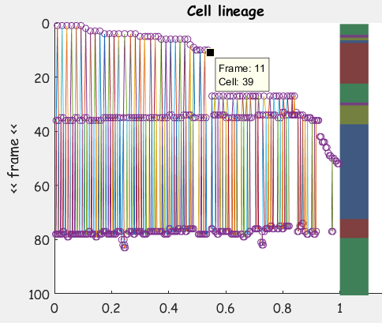

7. To check for irregularities in the segmentation process here, for example, you can ask:

-Do the nuclei divide at roughly the same time? (e.g. in the picture above, you see that they all divide at the ~40 mins and ~80 mins, so it is normal).

-Does each nucleus have two daughters?

You can click with Data tooltip on Irregular data points to see which frame and which nuclei ID they are.

Navigate to the frame with irregularities and press **Menu>Track>Check Track** to see the tracking results here.

Fix the frame image with the provided tools and restart the Track process.

When completed, the program will generate an output “**RED\_Track\_220.tif**”, which will be used in the spot detection process.

Press **Menu>Track>Set cycles** to manually specify the beginning and end frame of each nuclear cycle.

## 3. View modes

1. View modes on image panel:

There are 4 view modes, applied to the image panel:

|  |  |
| --- | --- |
| 1. Original   There is no mask added to this image |  |
| 1. Red mask   A red mask layer of the current frame is added to the original image |  |
| 1. Contour mask   A contoured mask of the current frame is added to the original image. This mode is helpful in checking the segmentation of closely spaced nuclei. |  |
| 1. Contour mask + projected red mask   The contour mask of the current frame is added on top of the red mask of previous frame.  The contour mask without overlapping red mask (orphaned nuclei) is marked as cyan. |  |

2. View modes on mask panel:

Tick on **Check ecc** to highlight eccentric nuclei and nuclei with too small size. This option will slow down the browsing through frames.

3. Zoom in/out:

Press **Zoom** at lower left corner to adjust the panel size.

4. View cell count:

Select **View>View Cell count** to view the total number of nuclei and nuclei with mother per frame.

This is helpful to check for masking consistency before the tracking process.

## 4. Nuclei segmentation (in details)

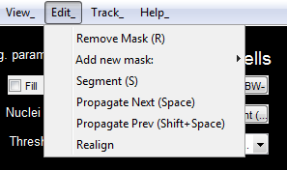 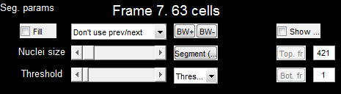

1. Segmentation strategy:

-We perform segmentation frame by frame.

-In each frame, we start with automatic segmentation first, followed by manual correction if needed.

-In automatic segmentation, the segmentation results and parameters of one frame can be used for the segmentation of the next, which should reduce the manual correction work.

-Get familiar with Hotkeys.

2. Automatic segmentation:

-There are 3 modes of automatic segmentation:

-Threshold 1: Basic filtering, thresholding and select only big nuclei

-Threshold 2: Basic filtering, thresholding and select medium and big nuclei

-Circle: The program will find circle-like objects. Helpful on NUP movies

-Select the proper **Nuclei size** and **Threshold** (top left) using the sliders. As you adjusting the sliders, you will see the binary mask corresponding to these values. The following nucleai segmentation will be based on this mask.

-Press  (hotkey **S**) to perform automatic segmentation using Thresholding method. If you are not satisfied, keep adjusting **Nuclei size** and **Threshold**.

3. Manual correction:

-Press  (hotkey **O** or **P**) to either increase or decrease the mask size of all nuclei by 1 pixel.

-Add a new nuclei **Edit>Add new mask**:

-You can choose to use **Free hand** tool (Hotkey A) or add an **Elliptic mask** (Shift+A)

-Remove a nuclei:  (hotkey **R**)

-Double click on the mask of nuclei to be removed in the Mask panel

4. Restrict the masking region



Adjusting the Top.fr and Bot. fr to select the vertical range of the masking region. All nuclei that border the specified region will be excluded from being segmented.

5. Set Auto-size params:



Normally, after the automatic segmentation for each frame, you need to manually adjust the size of masks to match that of nuclei. You can also specify the number of pixel you want to expand the size of all mask. This number (mostly probably positive, but can be set negative) requires few adjustment during the whole segmentation process.

## 5. Tracking

The tracking process is performed automatically. Here is a brief explanation of what is going on in the process of each frame:

1. Get the separate colored region from current frame’s mask. Each region corresponds to a single nucleus.

2. Get the projected mask from the previous frame using the alignment information. Attribute the nuclei from the current frame to the previous frame based on the overlapping mask.

3. Check if nuclei in the previous frame have more than one direct progenies in the current frame. If yes, assign new labels to the progeny and attribute them as daughters of the nuclei from the previous frames.

# III. Spot detection

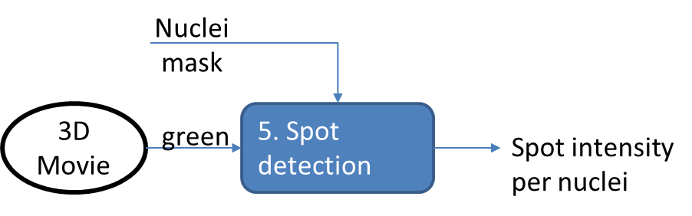

## 1. Spot detection

1. Open script Spot detection/LIVEFLY\_SPOTDETECTION.m

2. Specify the input movies and frame to be analyze

-Movie folder mov\_folder(e.g **“../Test”**)

-The original movie file (time-lapse, 3D, 2 channels with extension): main\_mov (e.g **“RAWMovie.tif”**)

-The nuclei movie file name: nuclei\_mov (e.g. **“RED.tif”**)

-Frame range to analyze. To test the spot detection function, it is recommended to select one or two frames with spots first.

3. Specify movie parameters (e.g shift\_left, shift\_right, dt …). These parameters are then saved in the local **table\_summary** folder and can be loaded for reanalysis if needed.

4. Set other spot detection criteria: It is good to have a look at the parameters’ comments and see what it means in the comment section.

5. Determine the threshold **th1 th2** for spot detection. Here, **th1** is the minimum absolute spot intensity and **th2** is the minimum absolute spot intensity above the local background level (determined using a median filter). These two values are used for the initial identification of the fluorescent spots. Only the brightest spot(s) located in the nucleus space are considered active transcription loci. The threshold values are determined as follow:

- Set either **th1** or **th2** to 0 to set the program in the debug mode.

- Select the frame in which you know that there is a spot by setting both **it\_start** and **it\_end** to its number. Run the script.

C:\Users\Anakine\Dropbox\REFLEX\METHOD_PAPER\Movie_analysis_tool\Fig4.tif- Zoom into the spot location and determine the threshold values, based on the two panels using MATLAB built-in Zoom In and Data Cursor.

-Set **th1** or **th2** and rerun LiveFly\_SPOTDETECTION.m

5. Check the spot detection process:

Check output\_images folder (in the script directory) to check the spot detection process.

## 2. Export the data

Set the frame to analyze to the whole movie and restart the script. The output file is that in the original movie file that has the file name “th[th1]\_[th2].txt”.

The header of the output file is in Header.txt of the script file for look up purpose.

# V. Finalizing the movie data:

To finalize the movie data, we need to create a file called “correction.m” in the same folder as the data file (here, referred as “movie\_data.txt”, instead of “th[th1] [th2].txt”).

The template for correction.m is located in Data analysis folder.

Have a look at the comment section. Copy the template from here and modify the file as seen fit. The correction file, though not strictly required for the analysis, is recommended. If you don’t have any exceptions to declare, you only need to specify the movie output file name.

# VI. LiveFly Visualizer

This section is under construction.